SIMATS ENGINEERING
ASSESSMENT TOOL 3: Game Based Learning Assessment
COURSE NAME: ARTIFICIAL INTELLIGENCE COURSE CODE: MLA0104
AND EXPERT SYSTEMS

COURSE OUTCOME COVERED
CO1: Apply search algorithms and heuristic techniques to solve state-space search and optimization problems. (BTL 3)
Assessment Tool Weightage: 40 %

Total Marks: 50 Time: 60 Mins
No. of Questions: 5
Annexure A
Game Based Learning Assessment

Code of Conduct:

I P Dinesh Reddy / 192525399 (Name / Reg No) certify that this submission is my original work and that I have adhered to the guidelines specified for this assessment. I understand that any violation of academic integrity rules will result in disciplinary action.

Signature of the student:

Criterion | Weightage | Marks Obtained
Understanding of the Problem / Game  Objective | 10%
Application of AI Search /  Problem-Solving Technique | 15%
Successful Completion of the Game /  Puzzle | 20%
Efficiency of Solution / Optimal Moves | 10%
Documentation / Evidence of  Completion | 15%
Understanding of the Problem / Game  Objective | 15%
Originality and Critical Thinking | 15%
Total | 100%
Signature of the Faculty Total Marks Awarded

Answer All the Questions

Q. No. |  | Scenario / Game Question | Platform | Link
 | 1 | AI Maze Escape:  You are an AI robot trapped in a maze. Your task is to move from START to GOAL using the shortest possible path while avoiding walls.  Challenge: Find the shortest path and record the number of steps taken. | Scratch | https://scratch.mit  .edu
 | 2 | N-Queens Challenge:  You are an AI chess strategist. Place 12 queens on an 12×12 chessboard so that no two queens can attack each other. Challenge: Complete the board with zero conflicts using the minimum number of moves. | Online N-Queens  Game | https://www.n-que ens.com
 | 3 | Water Jug Puzzle:  You are an AI agent solving a water jug problem. You have two jugs with capacities of 11 litres and 9 litres. Neither jug has measurement markings.  Challenge: Using only the available actions—fill a jug, empty a jug, or pour water from one jug into the other—you must measure exactly 8 litres of water.  Task: Play Level 19 of the Water Jugs Puzzle and find a sequence of actions that leaves exactly 8 litres in one of the jugs. Try to solve the puzzle using the minimum number of moves. | Tic-Tac-Toe | https://playtictact oe.org
 | 4 | Connect Four AI Challenge:  You are playing against an AI opponent. Your goal is to connect four of your pieces in a row before the AI does.  Challenge: Plan your moves carefully and defeat the AI opponent. | Connect Four | https://www.math sisfun.com/games  /connect4.html
5 |  | 8-Puzzle AI Challenge:  You are given a scrambled 8-puzzle. Move the tiles one at a time and arrange them in the correct order.  Challenge: Solve the puzzle using the minimum possible number of moves. | 8-Puzzle Game | https://8puzzle.org/

AI Maze Escape (BFS)
AI Maze Escape Logic
Represent the maze as a 2D grid.
Treat each empty cell as a node.
Start from the START position.
Use Breadth First Search (BFS) to explore all possible paths.
Visit neighboring cells (Up, Down, Left, Right).
Ignore walls and already visited cells.
Stop when the GOAL is reached.
Trace back the path to obtain the shortest route.
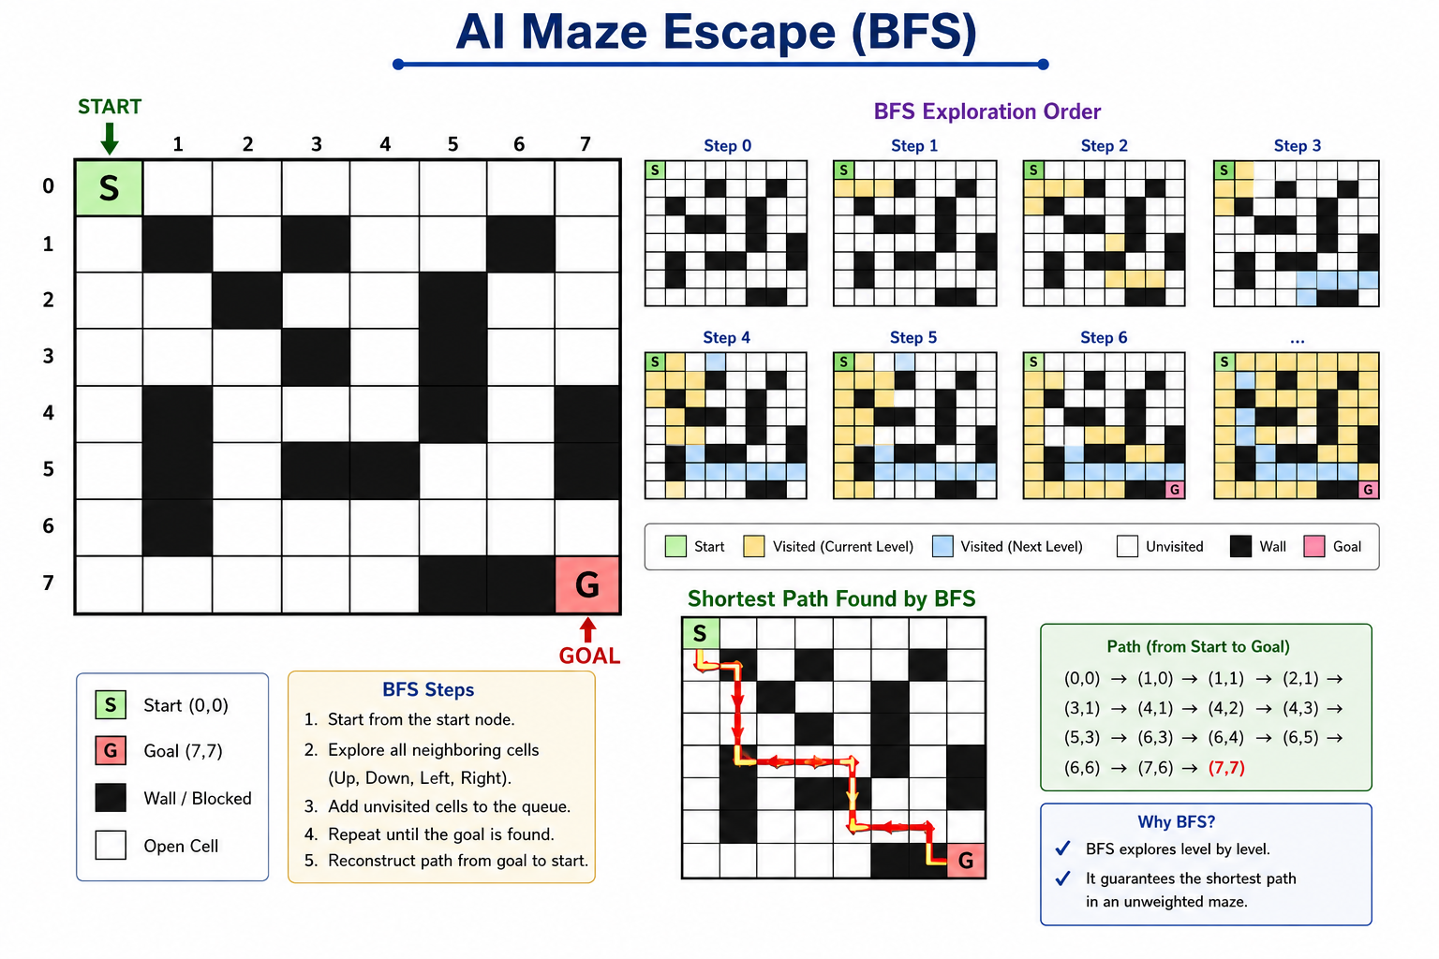
Pseudocode
```text
START
Initialize queue
Enqueue START node
Mark START as visited
WHILE queue is not empty
Dequeue current node
IF current node is GOAL
Display shortest path
STOP
FOR each neighboring cell (Up, Down, Left, Right)
IF neighbor is inside maze
AND neighbor is not a wall
AND neighbor is not visited
Mark neighbor as visited
Store parent of neighbor
Enqueue neighbor
END WHILE
END
```
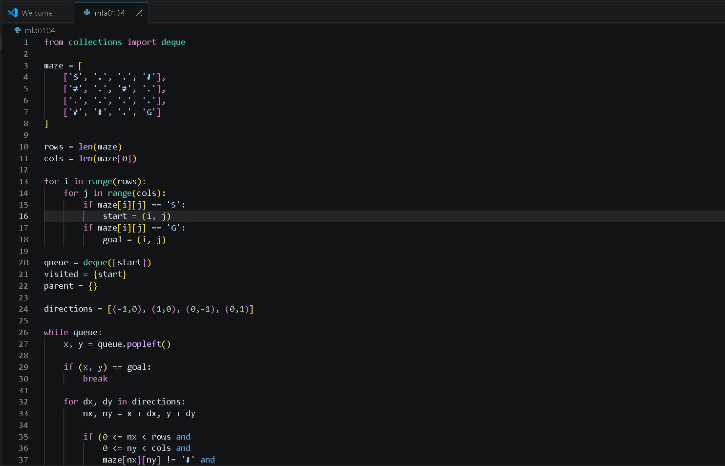
Python code
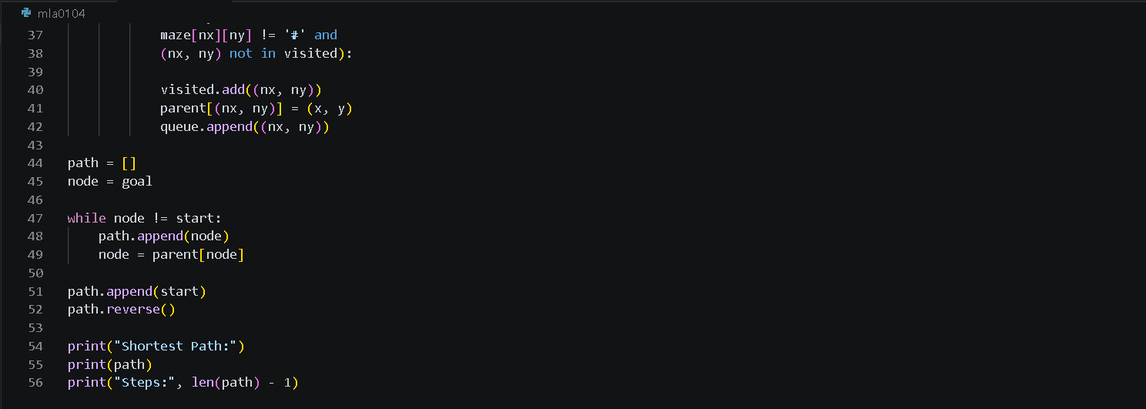
Output

N-Queens (Backtracking)

N-Queens Challenge Logic
Place one queen in each row.
Before placing a queen, check whether the position is safe.
A position is safe if no queen exists in the same column or diagonals.
If the position is safe, place the queen.
Continue placing queens in the next row.
If no safe position is found, remove the previous queen (backtracking).
Repeat until all queens are placed successfully.
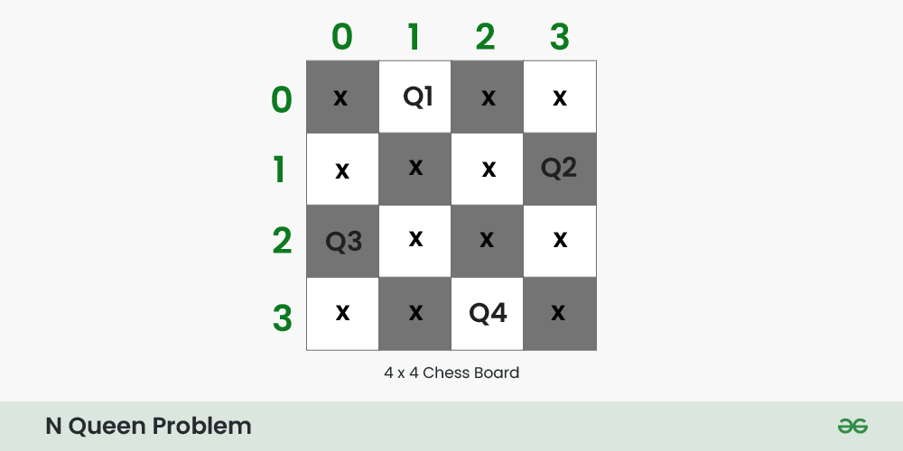
## Pseudocode
```text
START
FUNCTION Solve(row)
IF row == N
Display board
RETURN TRUE
FOR each column
IF position is safe
Place Queen
IF Solve(row + 1)
RETURN TRUE
Remove Queen
RETURN FALSE
CALL Solve(0)
END
```
Python code 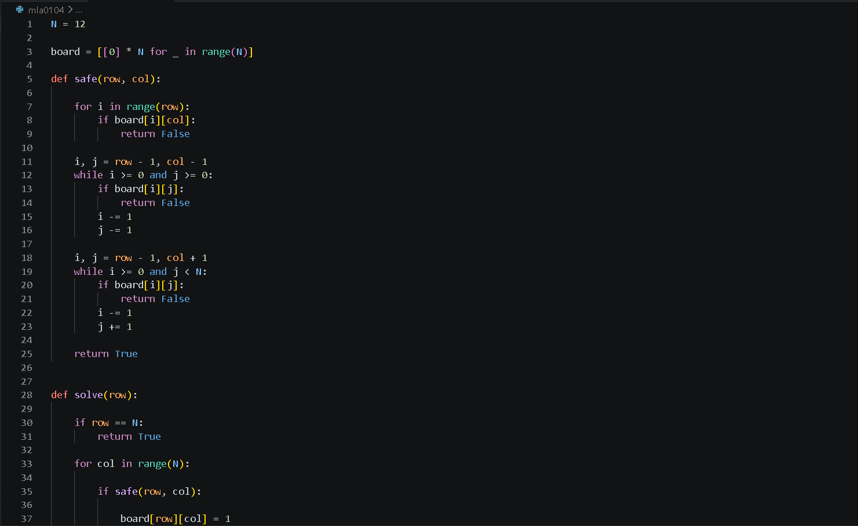
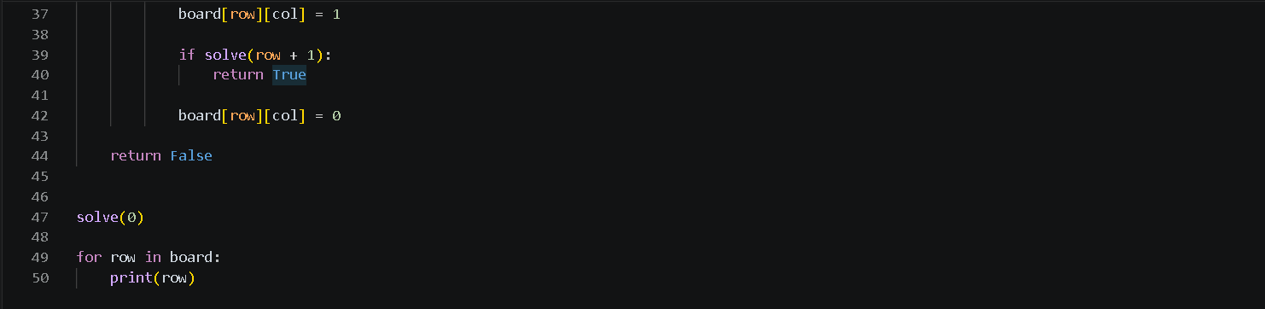
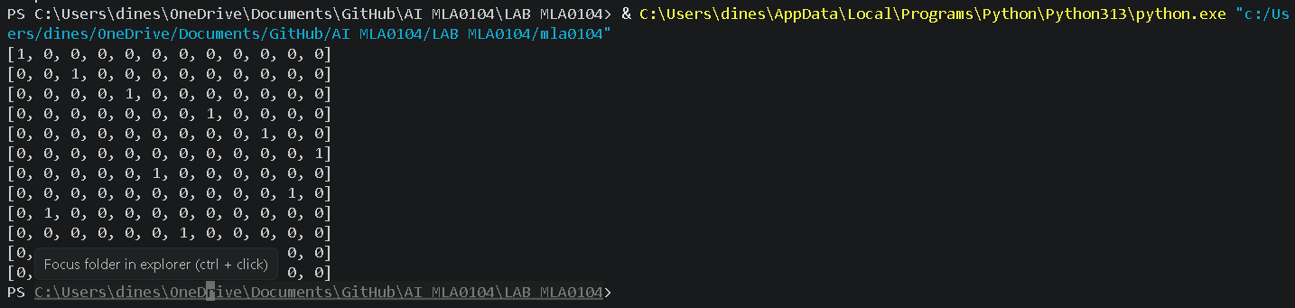
Output

Water Jug Puzzle (BFS)
Water Jug Puzzle Logic
Start with both jugs empty.
Generate all possible actions:
- Fill a jug.
- Empty a jug.
- Pour water from one jug to another.
Represent each water level as a state.
Use Breadth First Search (BFS) to explore all possible states.
Avoid revisiting previously explored states.
Continue until exactly 8 litres is obtained in one jug.
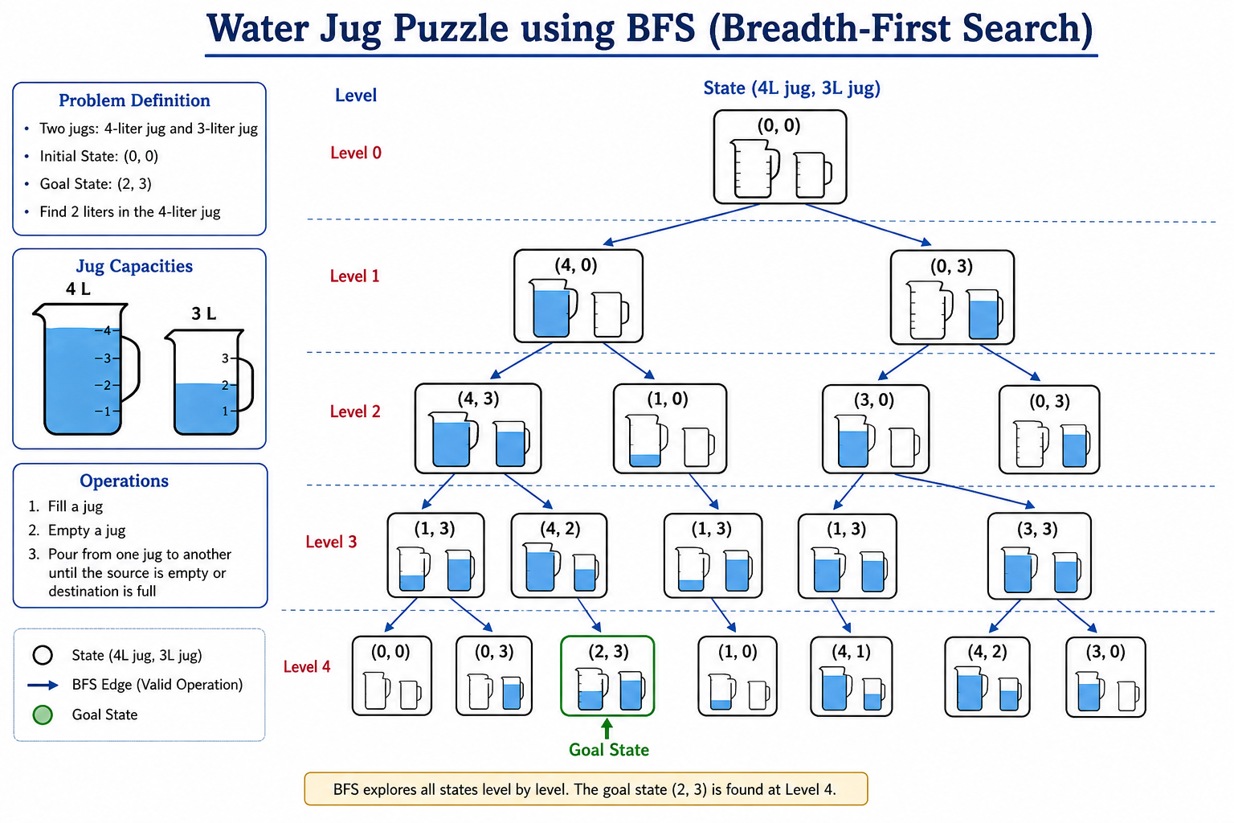
Display the sequence of actions taken.

Pseudocode
```text
START
Create queue
Insert initial state (0,0)
WHILE queue is not empty
Remove current state
IF target amount is found
Display solution
STOP
Generate all possible next states
Fill Jug1
Fill Jug2
Empty Jug1
Empty Jug2
Pour Jug1 → Jug2
Pour Jug2 → Jug1
Add unvisited states to queue
END WHILE
END
```
Python code
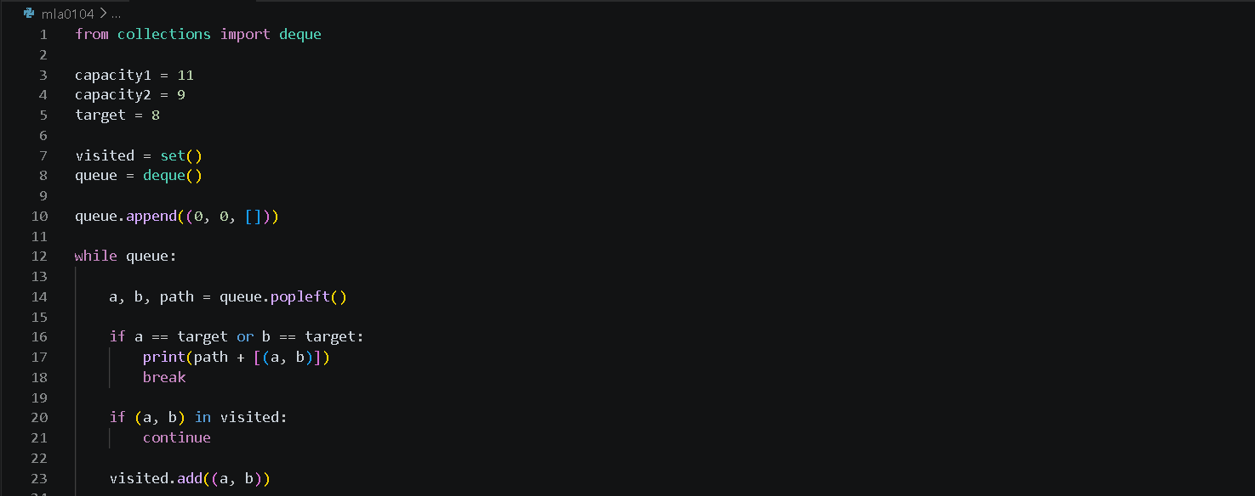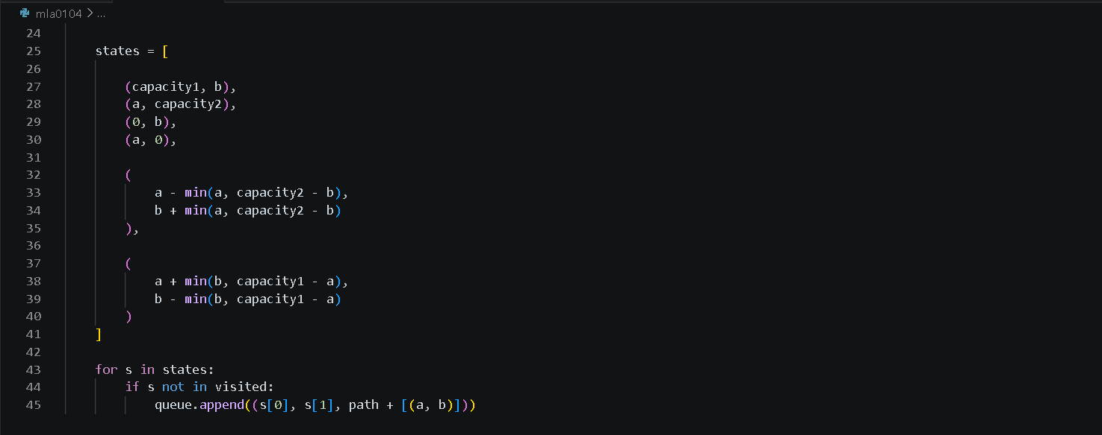
Output

Connect Four (Minimax)

Connect Four Logic

Create an empty 6×7 game board.
The human player makes the first move.
The AI evaluates all valid moves.
The AI selects the best move using the Minimax algorithm with Alpha-Beta Pruning.
Alternate turns between the player and the AI.
After every move, check for four consecutive pieces horizontally, vertically, or diagonally.
If a player connects four pieces, declare the winner.
If the board is full without a winner, declare a draw.
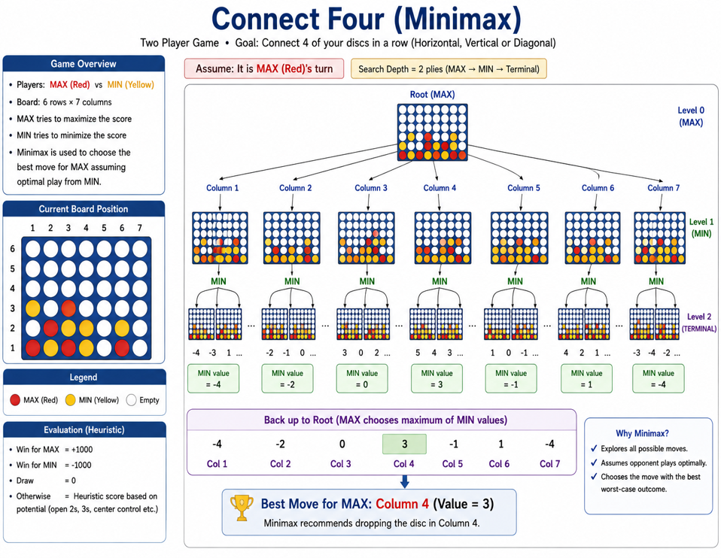
Pseudocode
```text
START
Create empty game board
WHILE game is not over
Player makes a move
IF player wins
Display "Player Wins"
STOP
AI evaluates all valid moves
Apply Minimax with Alpha-Beta Pruning
AI chooses the best move
IF AI wins
Display "AI Wins"
STOP
IF board is full
Display "Draw"
STOP
END WHILE
END
```
Python code
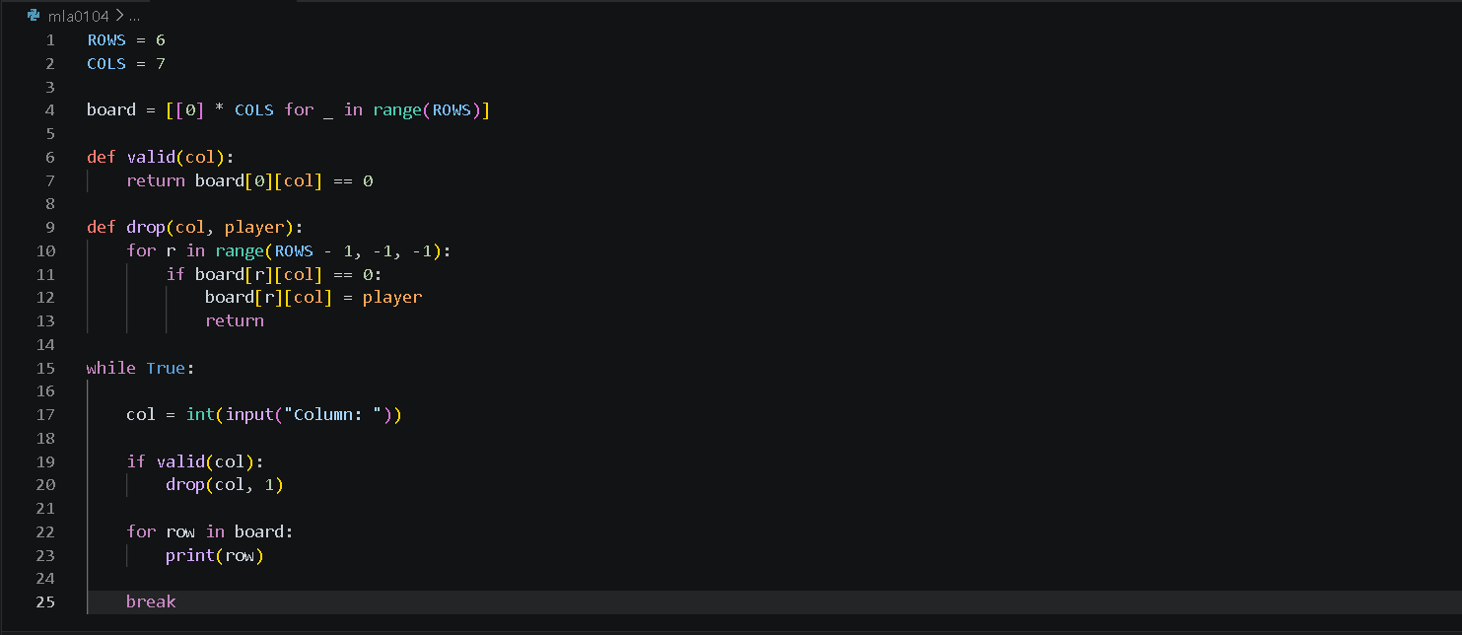
Output

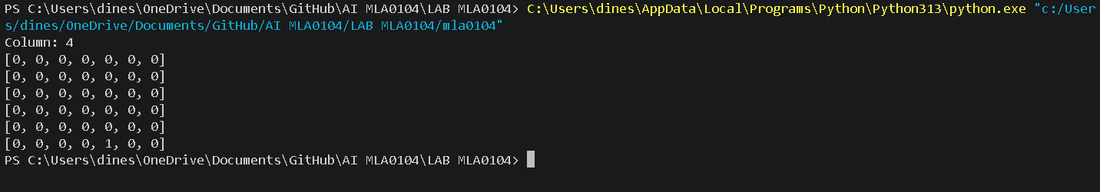

8-Puzzle (AI Search)

8-Puzzle AI Challenge Logic

Represent the puzzle as a 3×3 board.
Treat the blank tile (0) as the movable space.
Generate all possible moves of the blank tile.
Use the A* Search algorithm to find the optimal solution.
Calculate:
- g(n): Cost from the start state.
- h(n): Manhattan Distance heuristic.
- f(n) = g(n) + h(n).
Select the state with the smallest f(n).
Repeat until the goal state is reached.
Display the sequence of moves and the minimum number of moves required.
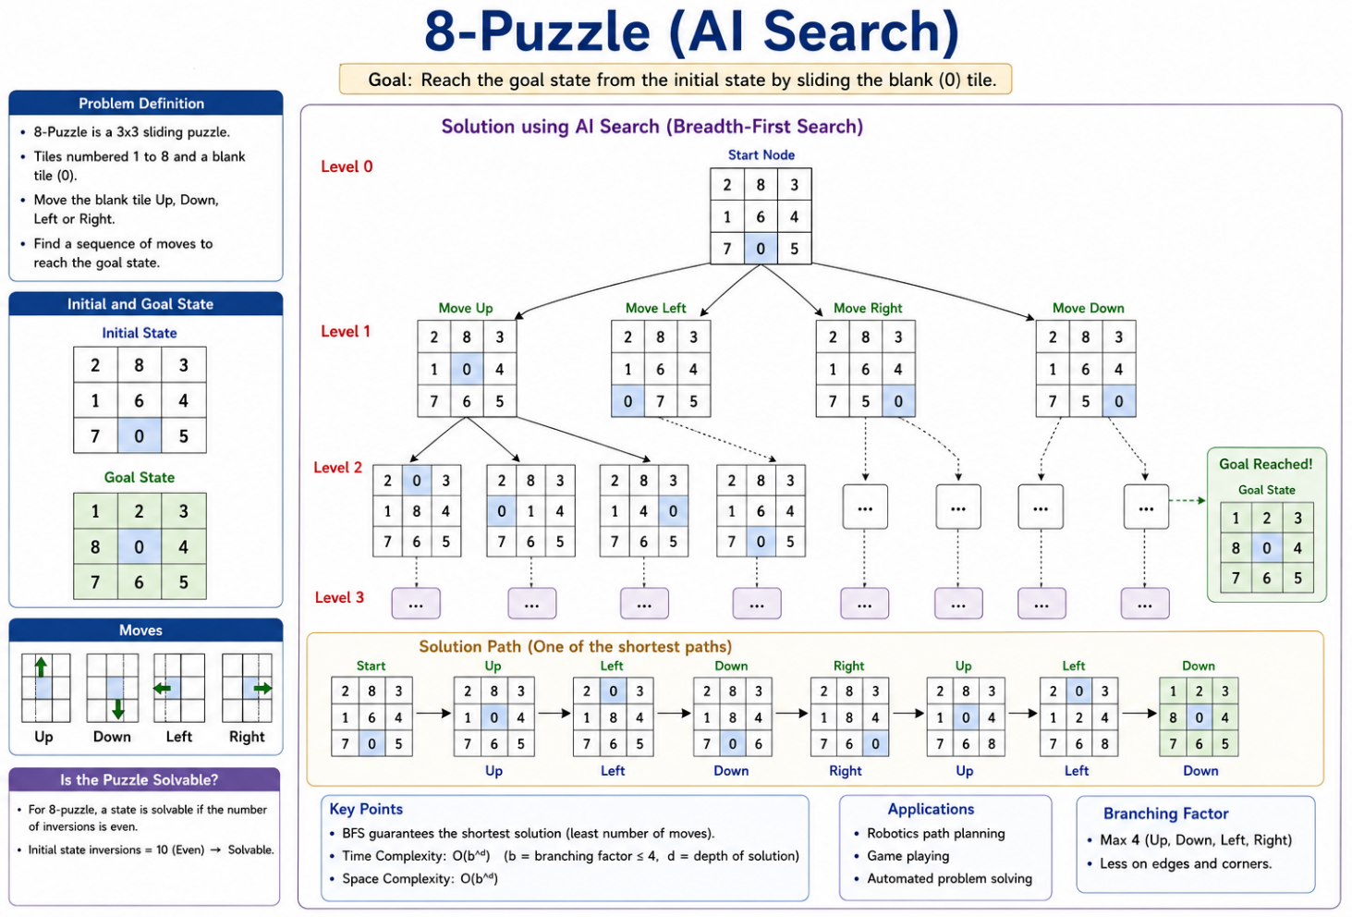
Pseudocode
```text
START
Create OPEN list
Insert initial state
WHILE OPEN list is not empty
Select state with lowest f(n)
IF state is GOAL
Display solution path
STOP
Generate all possible moves
Calculate
g(n) = Cost from start
h(n) = Manhattan Distance
f(n) = g(n) + h(n)
Insert new states into OPEN list
END WHILE
END
```
Python code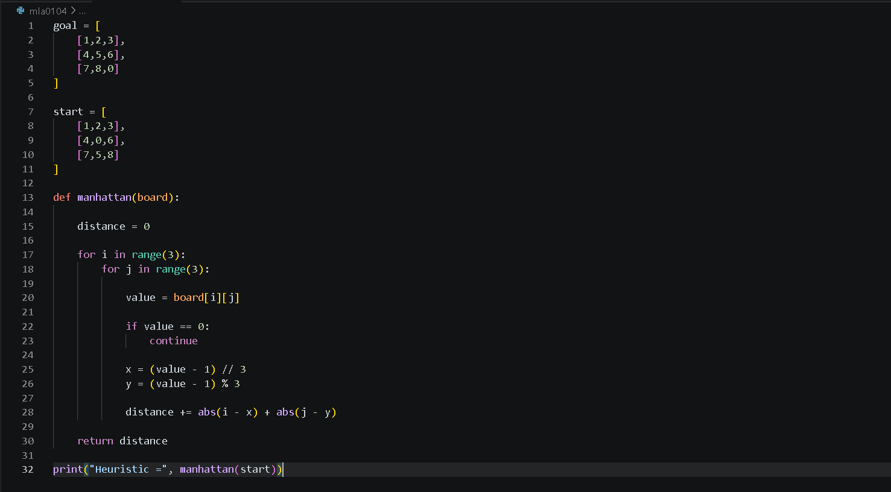
Output

Conclusion
This Game-Based Learning assessment helped in understanding how different Artificial Intelligence search and problem-solving techniques can be applied to solve real-world puzzles and games. The activities included Maze Escape, N-Queens, Water Jug Puzzle, Connect Four, and the 8-Puzzle, each demonstrating a different AI concept such as Breadth-First Search (BFS), Backtracking, Constraint Satisfaction, Heuristic Search, and Adversarial Search.
By completing these games, I learned how AI explores possible states, makes decisions, finds optimal solutions, and solves problems efficiently. The practical implementation using Python improved my understanding of search algorithms and strengthened my logical thinking, programming, and problem-solving skills. Overall, this assessment demonstrated the importance of AI techniques in developing intelligent systems capable of making effective and optimal decisions

Structure of the Report – Game-Based Learning
S.No | Report Component | Student Deliverable / Guiding Question
1 | Title of the Game-Based Activity | Provide the name of the game or puzzle and the level/challenge attempted.
2 | Game Platform / Link | Mention the platform or website used and provide the corresponding game link.
3 | Objective of the Activity | Explain the objective of the game and the target that needs to be achieved.
4 | Problem Statement | Describe the problem or challenge given in the game. What is the student required to solve?
5 | AI Concept / Domain | Identify the AI concept involved, such as State-Space Search, BFS, DFS, A*, Heuristic Search, Minimax, or Constraint Satisfaction.
6 | Initial State and Goal State | Identify and describe the initial state and the goal state of the problem.
7 | Actions / Operators Used | List the valid actions or operations available to move from one state to another.
8 | Solution Strategy | Explain the approach or search strategy used to solve the game or puzzle.
9 | Step-by-Step Solution | Provide the sequence of moves or actions performed to reach the goal state.
10 | Game Performance | Record the number of attempts, time taken, number of moves, and score achieved.
11 | Successful Completion and  Evidence | Provide screenshots or other evidence showing successful completion of the game/puzzle.
12 | Efficiency and Optimality | Analyse whether the solution was optimal or efficient. Can the puzzle be solved using fewer moves or less time?
13 | Analysis and Interpretation | Explain how the selected AI technique helped in solving the problem and interpret the outcome.
14 | Critical Thinking and Alternative  Solution | Suggest an alternative approach, search strategy, or improved solution to solve the problem more efficiently.
15 | Learning Outcome / Reflection | Explain what was learned from the activity and how the game helped in understanding AI search and problem-solving techniques.
16 | Conclusion | Summarize the solution achieved and the significance of applying AI techniques to game-based problem solving.
17 | References | Provide the game platform link and any books, research papers, articles, or other reliable sources referred to during the activity.
Structure of the Report – Game-Based Learning

Evaluation Rubrics

Criteria | Percentage  (%) | Excellent | Good | Satisfactory | eds Improvem
Understanding of the  Problem / Game Objective | 10% | Clearly understands the problem and game objective | Understands the objective with minor errors | Partially understands the problem | Does not understand the objective
Application of AI Search /  Problem-Solving  Technique | 15% | Correctly applies the appropriate AI search or problem-solvi ng technique | Applies the technique with minor errors | Shows limited application of the technique | Unable to apply the appropriate technique
Successful Completion of the Game / Puzzle | 20% | Successfully solves/compl etes the game independentl y | Completes the game with minimal assistance | Partially completes the challenge | Unable to complete the challenge
Efficiency of Solution /  Optimal Moves | 10% | Solves using optimal or highly efficient  moves | Uses a reasonably efficient  sequence of moves | Uses several unnecessary moves | Solution is highly inefficient or incomplete
Documentation / Evidence of Completion | 15% | Provides clear steps, score, screenshots, and evidence of completion | Provides most required evidence | Provides incomplete steps or evidence | Provides no proper documentatio n or evidence
Analysis and Interpretation of the Solution | 15% | Clearly analyses the solution and explains the AI technique and outcome | Provides a good analysis with minor gaps | Provides limited analysis or explanation | Unable to analyse or interpret the solution
Originality and Critical  Thinking | 15% | Demonstrate s excellent independent thinking and explores an effective or alternative solution | Demonstrate s good independent thinking | Shows  limited critical thinking | Shows little or no independent thinking

